**Reg. No. 21BCE1297 Name: Vidhi Shah Date of Practical: 20/04/22**

**Experiment 8**

**Aim:**

Simulation of RC Phase Shift Oscillator using LT Spice

**Tools and Apparatus:**

­LTSpice, BJT Transistor, Resistors, Capacitors, Voltage Sources

**Theory and Design:**

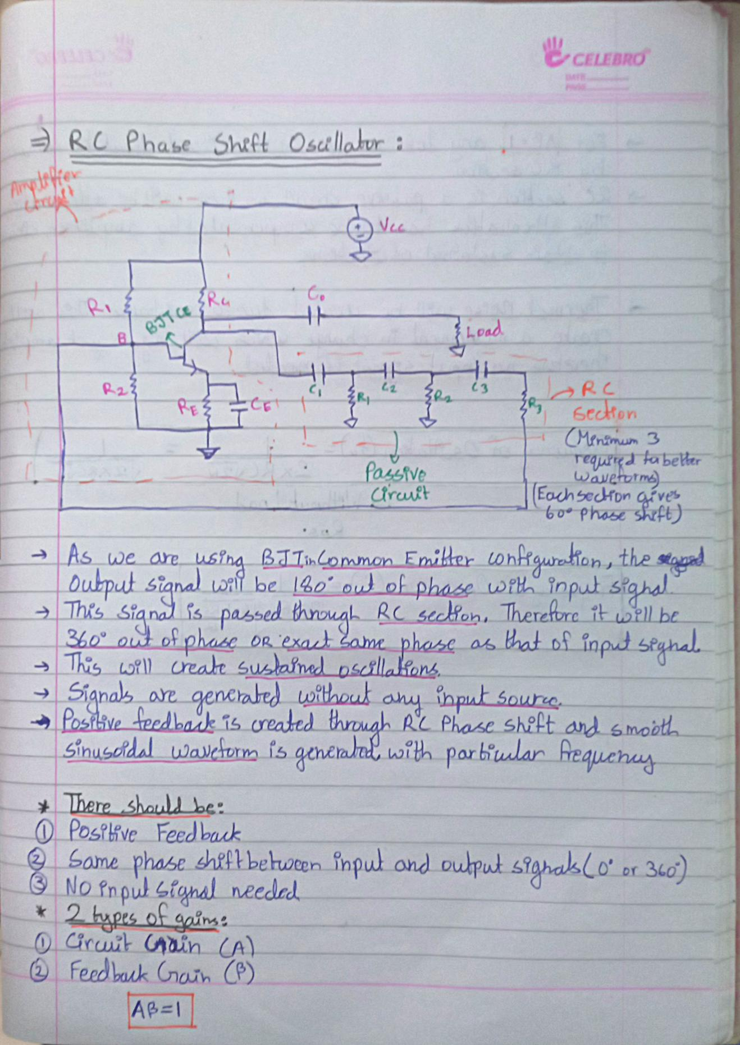

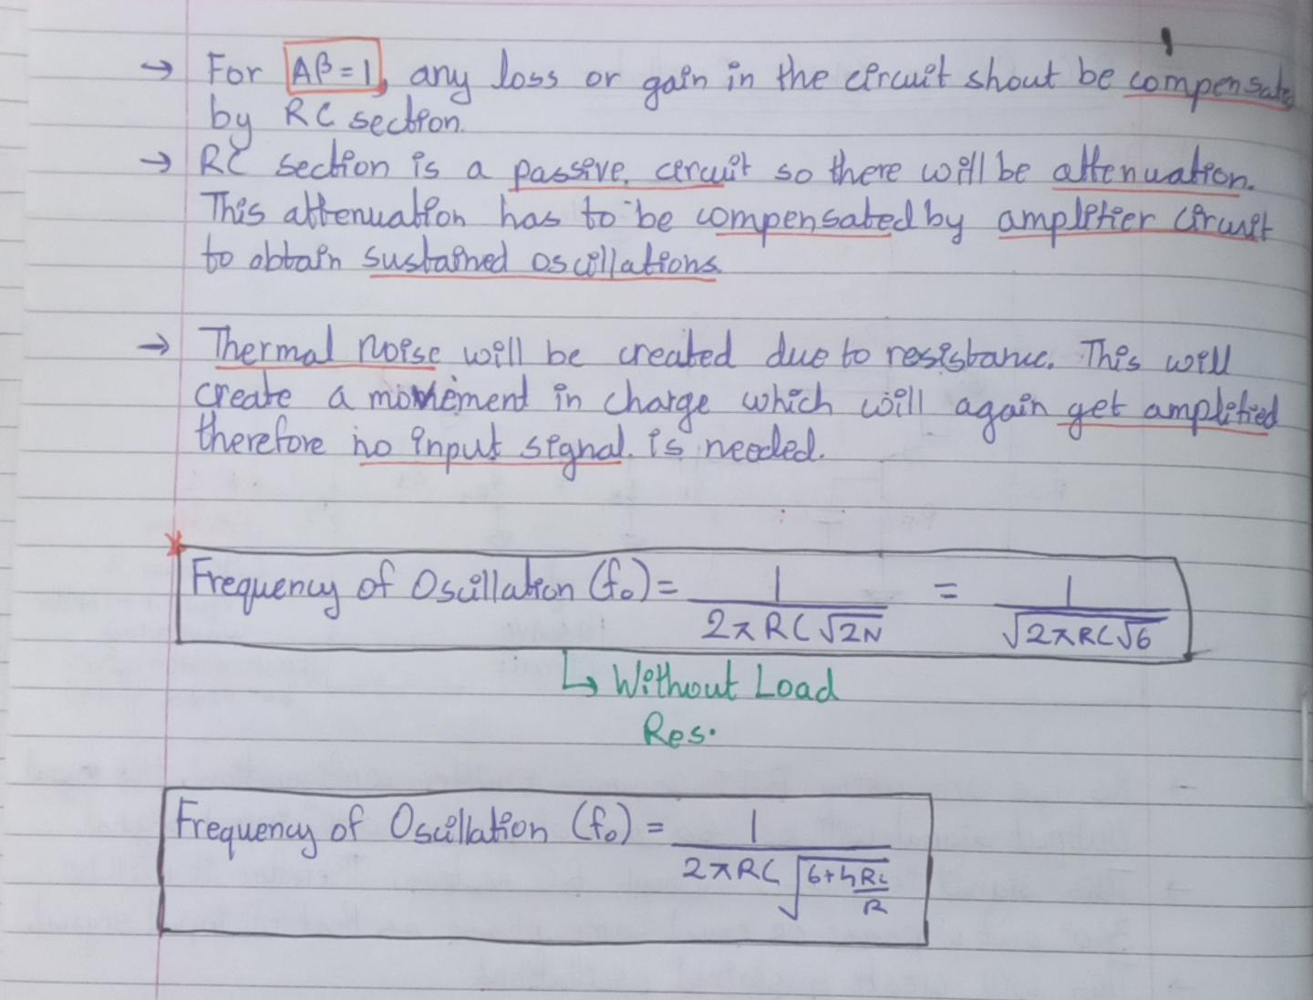

**Simulation Results:**

1. **With Load**

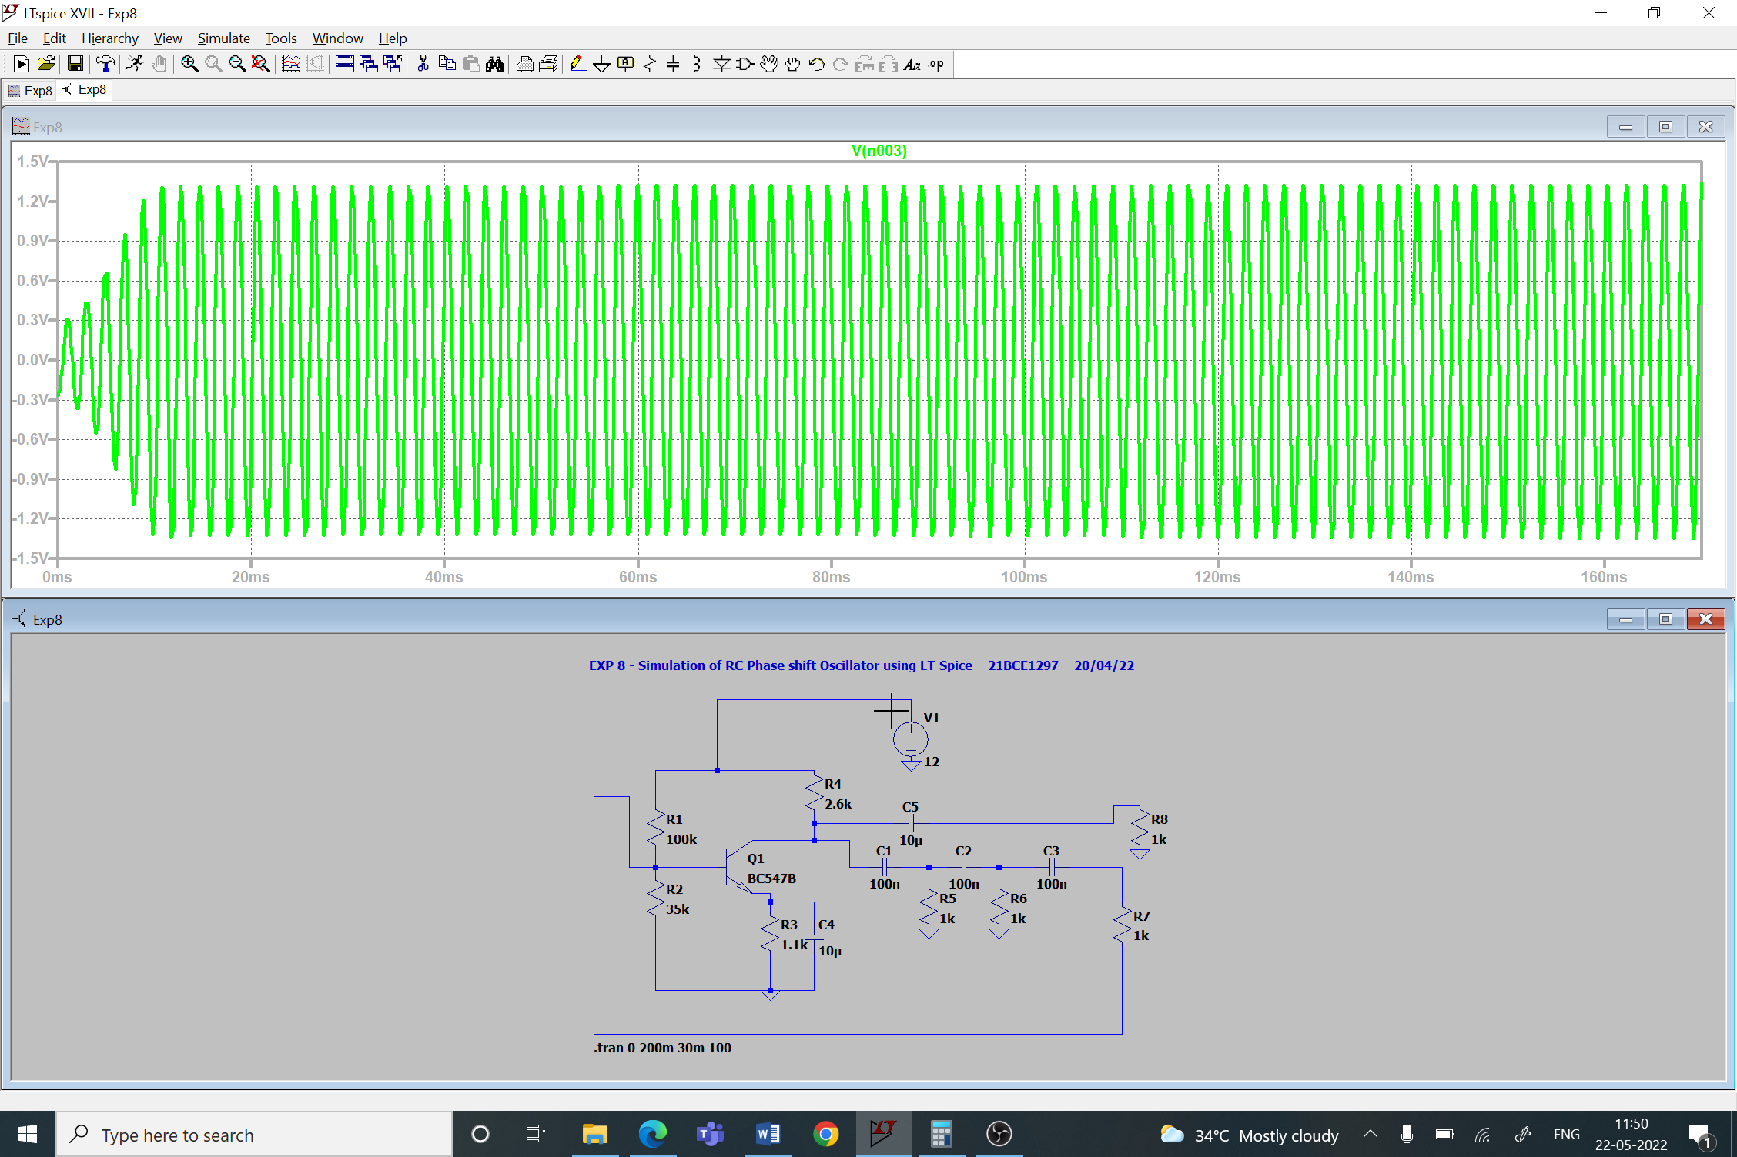

1. **Without Load**

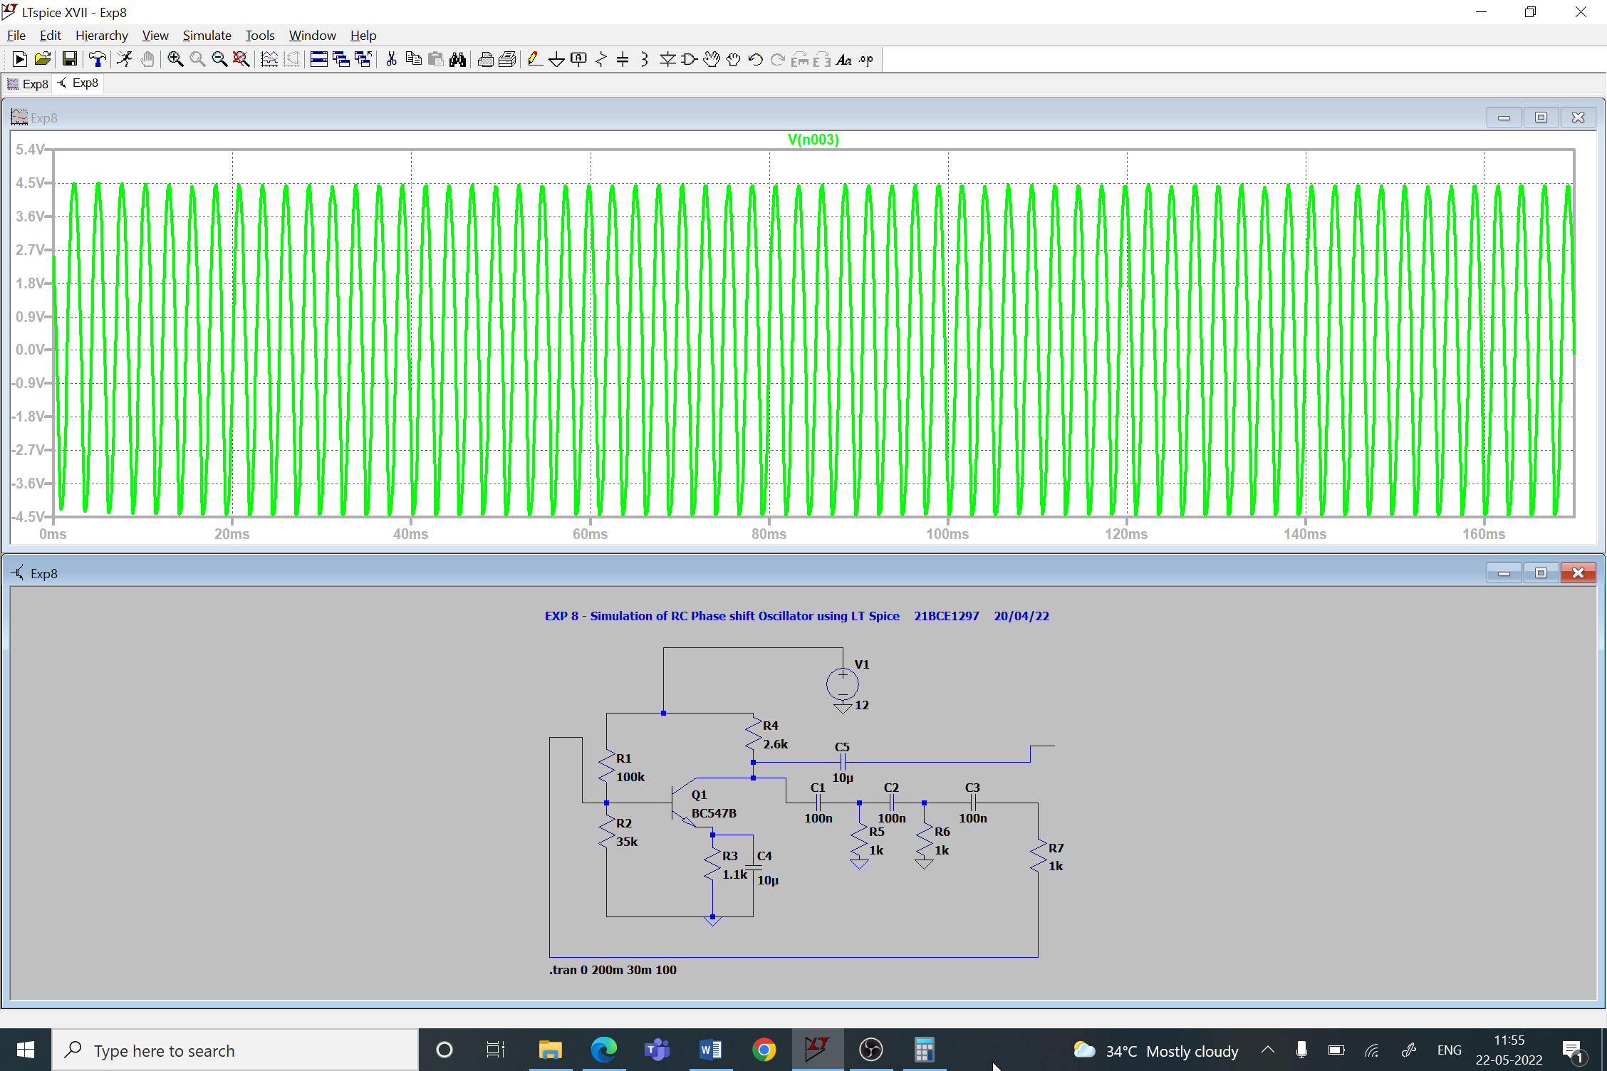

**Conclusion:**

1. **With Load:**

* f0 = = 517.15 Hz (Simulated)
* f0 = = 649.75 Hz (Calculated)

1. **Without Load:**
   * f0 = = 386.6 Hz (Simulated)
   * f0 = = 393.005 Hz (Calculated)

**Inferences:**

1. **Oscillation frequency (f0)**:
   1. With Load: 500-600 Hz
   2. Without Load: 350-400 Hz
2. It gives positive feedback and no input source is needed.
3. Minimum 3 RC sections should be connected to obtain better waveform
4. Marginal error occurs between stimulated and calculated values due to loading effect.
5. Connect all components properly.